Global Layoffs Trend Analysis(2020-2025)
Introduction
- In recent years, many organizations across the world have experienced workforce reductions due to economic uncertainty, technological advancements, and changing business strategies. Layoffs have become a significant trend affecting multiple industries and countries.
- This project focuses on analyzing global layoffs data from 2020 to 2025 to understand patterns, trends, and key factors influencing workforce reduction. By applying data analytics techniques, the project aims to provide meaningful insights that can help organizations and decision-makers better understand the dynamics of layoffs.
Problem Statement
- Although layoffs are widely reported, it is difficult to clearly identify which industries and regions are most affected and how these layoffs change over time.
- Organizations often lack a clear understanding of patterns in layoffs, making it challenging to take proactive decisions.
- Therefore, this project aims to analyze layoffs data to identify trends, patterns, and relationships between different factors such as industry, country, funding, and time.
Objectives
- To identify industries with the highest number of layoffs
- To analyze layoffs distribution across countries
- To find companies with the largest layoffs
- To study trends in layoffs over time
- To understand the relationship between funding and layoffs
Dataset Information
The dataset used in this project is obtained from Kaggle, which compiles information from Layoffs.fyi.
The dataset contains detailed information about layoffs reported globally, including:
- Company name
- Industry
- Country
- Total layoffs
- Percentage of layoffs
- Funds raised
- Stage of company
- Date of layoff
- Source and date added
This dataset provides a comprehensive view of layoffs across different dimensions.
Data Cleaning and Preprocessing
Data cleaning is an important step to ensure accuracy and reliability of analysis. The following steps were performed:
- Missing values were identified and handled appropriately
- Rows with critical missing values were removed
- Duplicate records were removed to avoid redundancy
- The date column was converted into proper datetime format
- A new column “Year” was extracted for trend analysis
- Data types were corrected for numerical and categorical variables
After cleaning, the dataset became consistent and suitable for analysis.
Exploratory Data Analysis (EDA)
Univariate Analysis
Univariate analysis was performed to understand individual variables.
- Histogram was used to analyze distribution of total layoffs
- Countplot was used to understand distribution of industries
- Boxplot was used to detect outliers
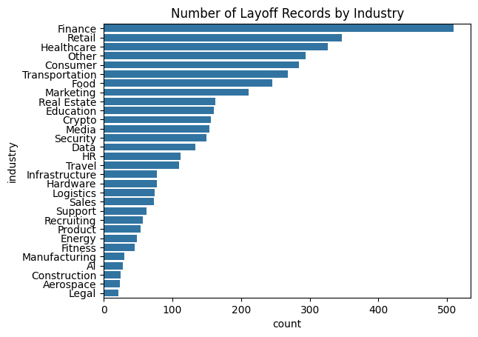
Interpretation Example:
The distribution shows that most companies have smaller layoffs, while a few companies have extremely large layoffs, indicating the presence of outliers.
Bivariate Analysis
Bivariate analysis was used to understand relationships between two variables.
- Bar chart → Industry vs Layoffs
- Bar chart → Country vs Layoffs
- Scatter plot → Funding vs Layoffs
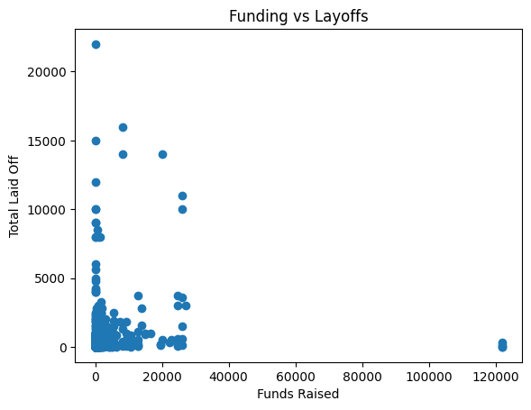
Interpretation Example:
The analysis shows that the technology industry has the highest layoffs, while the scatter plot indicates no strong relationship between funding and layoffs.
Multivariate Analysis
Multivariate analysis helps understand multiple variables together.
- Line chart → Year-wise layoffs trend
- Grouped analysis → Industry over time
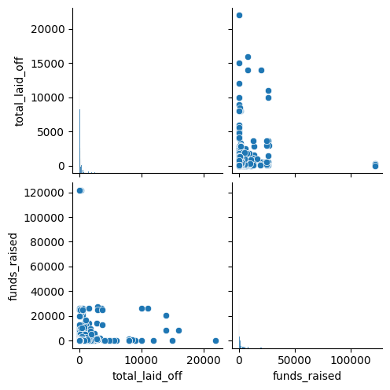
Interpretation Example:
Layoffs have increased significantly in recent years, indicating economic and business challenges.
Key Insights
- The technology industry experienced the highest layoffs
- Layoffs have increased significantly over time
- A small number of companies contributed to large layoffs
- Layoffs are concentrated in certain countries
- No strong relationship between funding and layoffs
Dashboard Explanation
A dashboard was created using Microsoft Power BI to visualize the data in an interactive way.
The dashboard includes:
- KPI cards showing total layoffs and companies
- Charts showing layoffs by industry and country
- A trend line showing layoffs over time
- A scatter plot showing funding vs layoffs
The dashboard allows users to filter data and gain insights quickly.
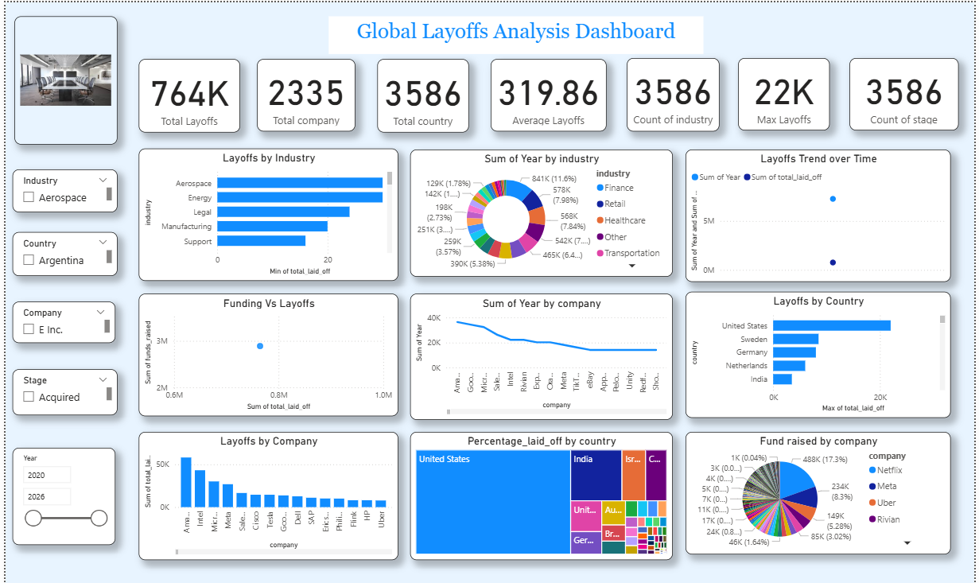

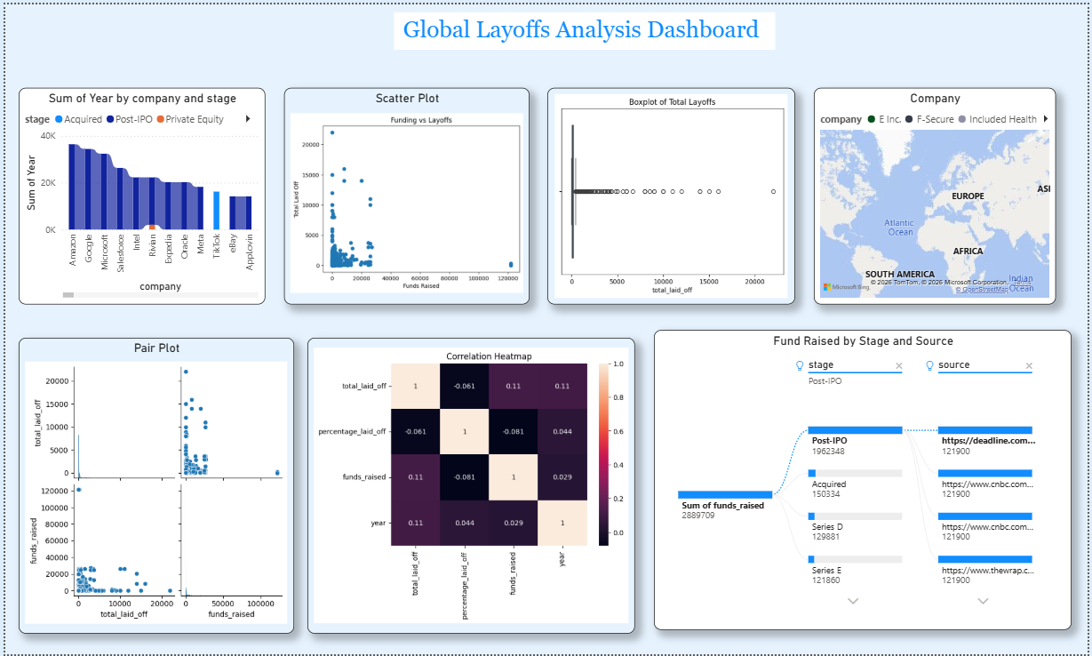

Business Insights
The analysis shows that layoffs are concentrated in specific industries and regions rather than being evenly distributed.
The technology sector is the most affected, and layoffs have increased over time.
Even companies with strong financial backing are reducing workforce, indicating that layoffs are driven by strategic decisions as well as economic conditions.
Recommendations
- Improve workforce planning
- Invest in employee reskilling
- Diversify business strategies
- Optimize costs before layoffs
- Government support for affected sectors
Conclusion
This project provides a comprehensive analysis of global layoffs trends and highlights important patterns across industries and regions.
The insights derived from this analysis can help organizations and decision-makers better understand workforce reduction and make informed strategic decisions.

